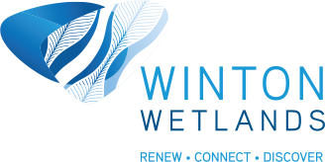

Compatible land use?

Locations:
Within Winton Wetlands
North of Winton Wetlands (north side of Lake Mokoan Road
East of Winton Wetlands (other or east side of Glenrowan-Boweya Road)
South of Winton Wetlands (along both sides of the Hume Freeway)
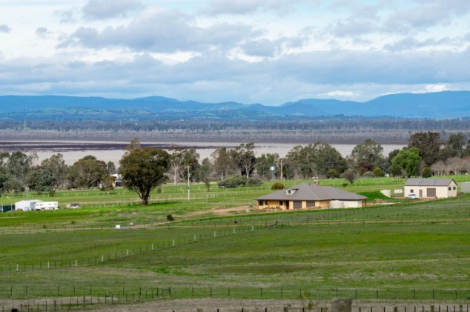
West of Winton Wetlands (below dam wall)

Equipment

Recording materials
Hard copy and/or digital maps

Data gathering

While driving
- Through Winton Wetlands
- Along Lake Mokoan Road looking north
- Along Glenrowan-Boweya Road looking east
- Along the Hume Freeway looking on both sides of the freeway
- On the dam wall looking west

Record the types of land use by recording on the data sheet, recording on maps and taking photos.

Record:
- Type of Land Use
- Approximate percentage
- If the type of land use has recently changed (ie new to the location/region)?
- If the land use is compatible with Winton Wetland environment (WWE)?

Through Winton Wetlands
Along Lake Mokoan Road looking north
Along Glenrowan-Boweya Road looking east
Along the Hume Freeway looking on both sides of the freeway
On the dam wall looking west

Land use

Land use | Within Winton Wetlands |  |  |  | North |  |  |  | East
 | Yes | Approx % | Changing | Compatible with WWE | Yes | Approx % | Changing | Compatible with WWE | Yes | Approx % | Changing | Compatible with WWE
Agriculture
Livestock grazing
Dairy
Feedlot incl. pigs
Chickens
Cropping
Orchards, vineyards
Other agriculture
Forestry
Recreation
Picnic areas
Walking
Cycling
Nature activities
Canoeing
Fishing
Powerboats
Other land use
Nature conservation
Mining
Aboriginal heritage
Built environment
Housing
Commercial buildings
Other
Land use

Land use | South |  |  |  | West
 | Yes | Approx % | Changing | Compatible with WWE | Yes | Approx % | Changing | Compatible with WWE
Agriculture
Livestock grazing
Dairy
Feedlot incl. pigs
Chickens
Cropping
Orchards, vineyards
Other agriculture
Forestry
Recreation
Picnic areas
Walking
Cycling
Nature activities
Canoeing
Fishing
Powerboats
Other land use
Nature conservation
Mining
Aboriginal heritage
Built environment
Housing
Commercial buildings
Other

What are the spatial changes between Winton Wetlands and the region surrounding it?

What are the land use changes at Winton Wetlands and the region surrounding it?

How does agriculture impact on the Winton Wetland ecosystem?

Compared with grazing, how would more intensive agriculture impact more on the wetlands?

Why is grazing encouraged in some sections of Winton Wetlands?

Looking at land use, what activities provide employment?

What are the best prospects for creating additional employment in this region outside of the towns?

How is Winton Wetlands creating employment?

What can Winton Wetlands do to generate more employment in the future?

