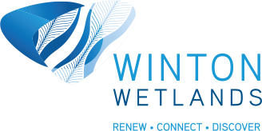
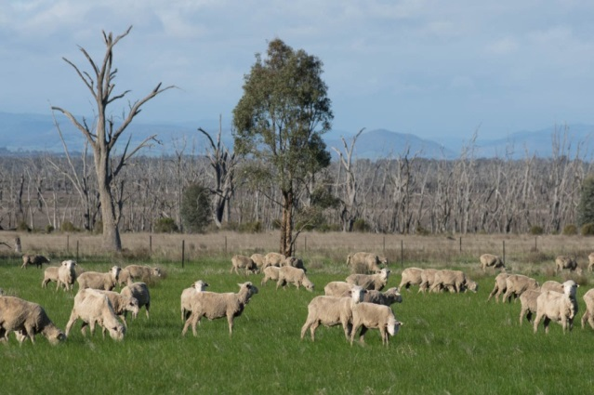

Land Use Outcomes

Location:
Observe and record while travelling around Winton Wetlands

Equipment and materials:
Writing materials
Phone or camera for taking images

Measuring change:
Below are the outcomes and some suggestions of what kind of evidence can be gathered. Students may wish to take and annotate photos to include in their data gather.

Table 9: Key land use outcomes
Outcome: Land Use Outcome Sought | Examples that can be investigated
Outcome 1: Ensure all options suggested by the community are identified and commented on | Are there a range of community views on the graphic panels?
Outcome 2: Restore the Winton Wetlands | What evidence can be seen for habitat restoration?
Outcome 3 Ensure the adjacent land uses are compatible with the wetland system | Are highly polluting activities seen nearby?
Outcome 4 Ensure the adjacent land uses are compatible with existing surrounding land uses | Is most of the land around Winton Wetlands still used for farming?
Outcome 5 Ensure that land uses can be viably developed | Ask Winton Wetlands staff.  Observe if there are cattle and sheep grazing within the boundaries of Winton Wetlands.
Outcome 6 Optimise community access | Is there a comprehensive set of drivable roads and walking and cycling tracks?
Outcome 7 Benefit local and regional economics | Is there evidence of other large attractions in this is region that can also be developed?
Outcome 8 Ensure a mix of private and public ownership | Who runs the restaurant?
Outcome 9 Ensure public funding is aimed at beneficial environmental and community outcomes | Look at Winton Wetlands website for current community activities  Identify the changes around Winton Wetlands and identify the benefits
Outcome 10 Minimise management complexity | Ask Winton Wetlands staff. Look at the Winton Wetland website

Preparation and background information

As part of Winton Wetlands land use strategy, 10 outcomes have been identified. Students can record what evidence for some or all of these outcomes are being implemented around Winton Wetlands as they travel around the area.

Ref: Winton Wetlands Land use Strategy Part II pages 6 - 8

Land Use Outcomes
Outcome: Land Use Outcome Sought | Evidence and location
Outcome 1: Ensure all options suggested by the community are identified and commented on

Outcome 2: Restore the Winton Wetlands

Outcome 3 Ensure the adjacent land uses are
compatible with the wetland system

Outcome 4 Ensure the adjacent land uses are compatible with existing surrounding land uses

Outcome 5 Ensure that land uses can be viably developed

Outcome 6 Optimise community access

Outcome 7 Benefit local and regional economics

Outcome 8 Ensure a mix of private and public ownership

Outcome 9 Ensure public funding is aimed at beneficial environmental and community outcomes

Outcome 10 Minimise management complexity

